

Javad Malek Shahkoohi S224309 | System Programming | January 14, 2016

Kernel Driver

Compile and install the new kernel

# Exercise 1:

# Download 3.3.x version of the Linux kernel and decompress it. Configure the new kernel, justifying the choices. Don’t forget to save the running configuration file (in order to be able to replicate the laboratory at home). Compile and install the new kernel, paying attention to preserve the old running kernel. Verify the grub configuration as seen in the slides. Download exercises of the book “Writing Linux Device Drivers” Jerry Cooperstein ISBN 978-1448672387, from: http://www.coopj.com/LDD. Copy and verify the 32 bit kernel configuration file, adjusting it if required. Finally compile and install the kernel. Do not forget that the compliant Ubuntu version for the task is the 12.x LTS.

# Step 1: Downloading the Linux kernel version 3.6.2 from <http://kernel.org/pub/linux/kernel/v3.0/linux-3.6.2.tar.bz2> by wget command in Linux Terminal

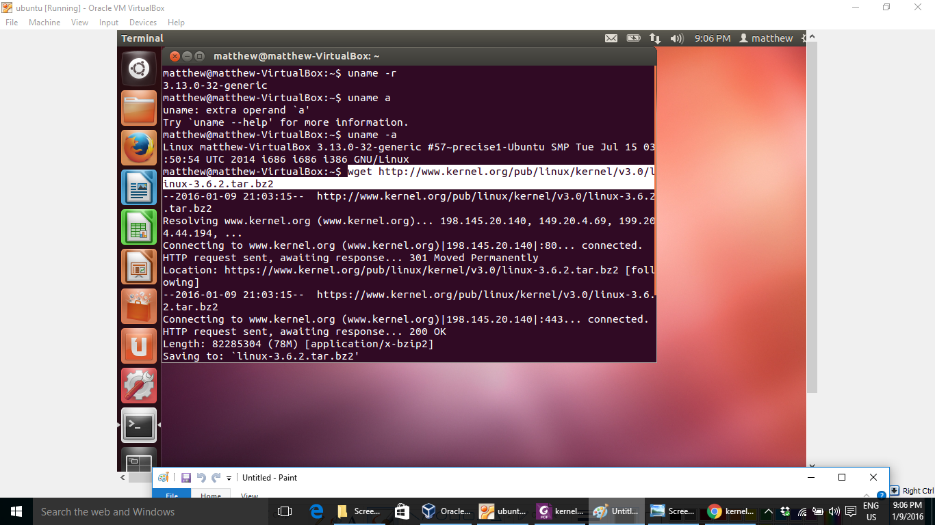

Figure 1 Downloading the Linux kernel

# Step2: Decompressing the kernel downloaded file by tar xvf linux-3.6.2.tar.bz2 command

# C:\Users\Steve\AppData\Local\Microsoft\Windows\INetCache\Content.Word\Screenshot 2016-01-09 21.06.48.png

Figure 2 decompressing the kernel file

# Step3: Installing the ncurses-dev package on Linux by sudo apt-get install ncurses-dev

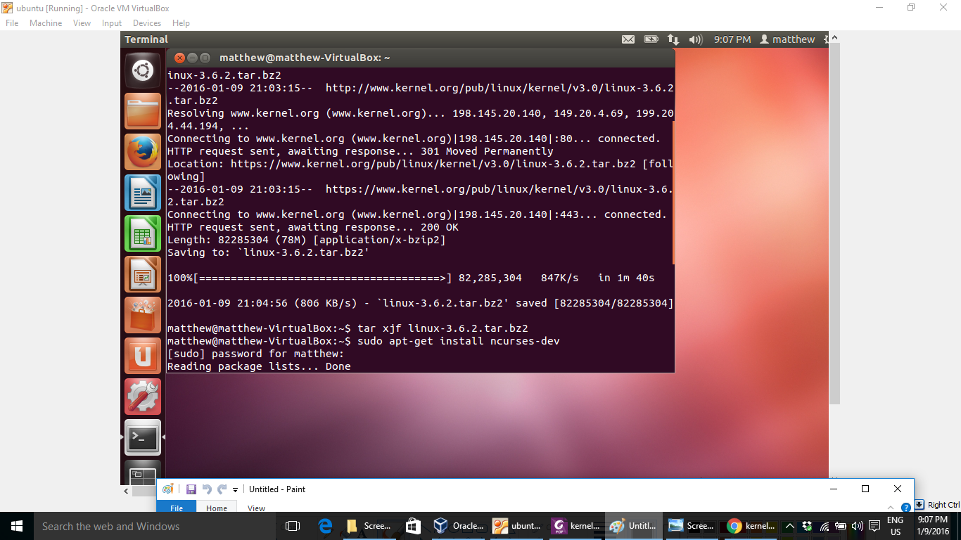

Figure 3 installing ncurses-dev package

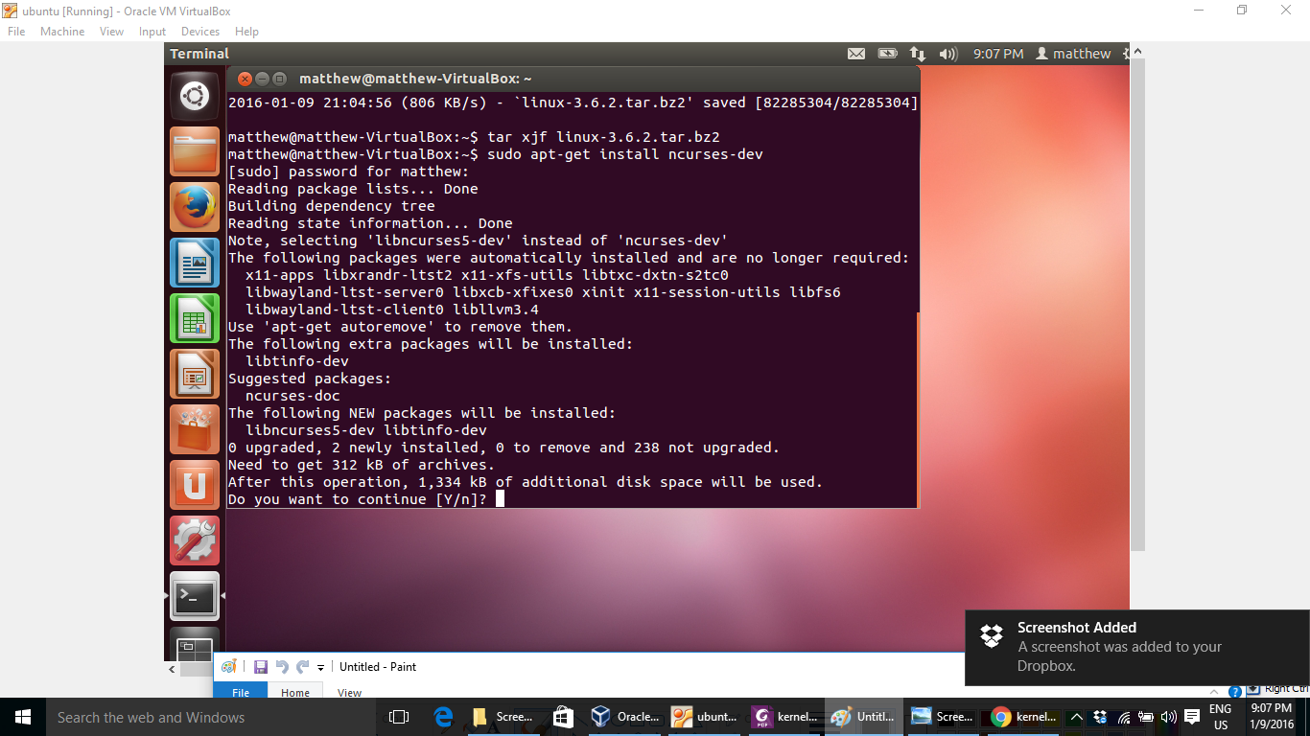

Figure 4 asking for additional disk space

# Step4: Entering to source directory which is extracted from tar file by cd linux-3.6.2 and watching the existed files by ls –l

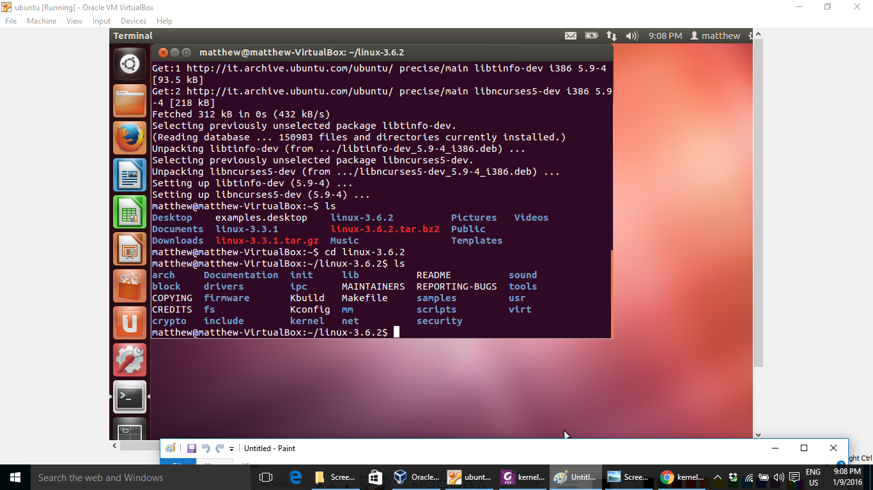

Figure 5 entering to source files directory

# Step5: making mrproper and installing g++ and libqt4-dev by make mr proper , sudo apt-get install g++ and sudo apt-get install libqt4-dev

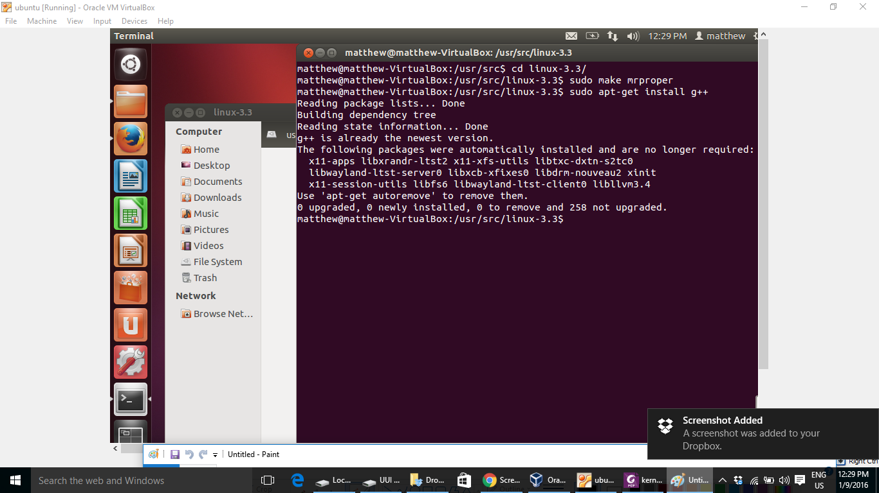

Figure 6 making mrproper and installing g++

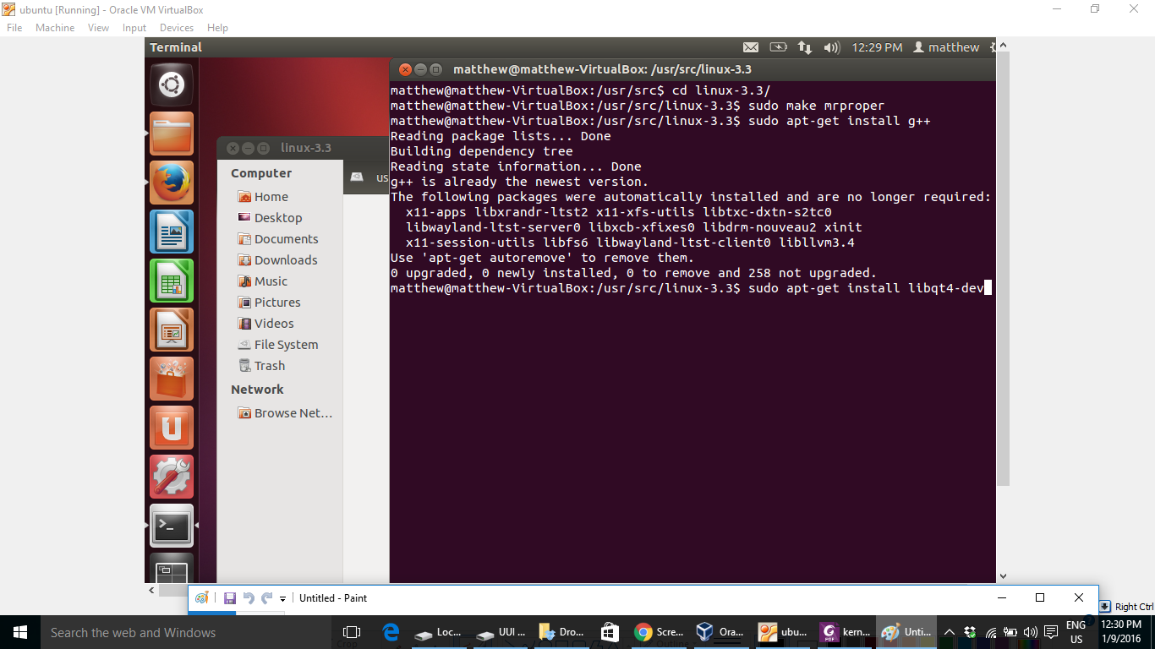

Figure 7 installing libqt4-dev

# Step6: making menuconfig for setting up the configuration of compliment by make menuconfig

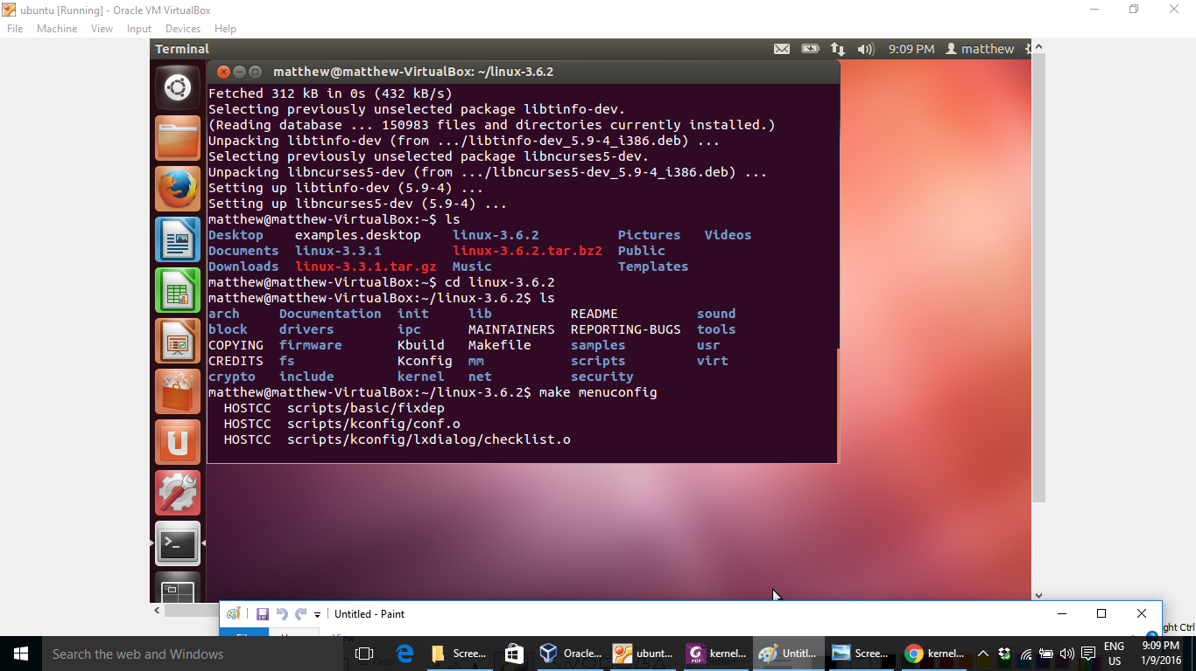

Figure 8 making menuconfig

Selecting and deselecting items which are essential for compile

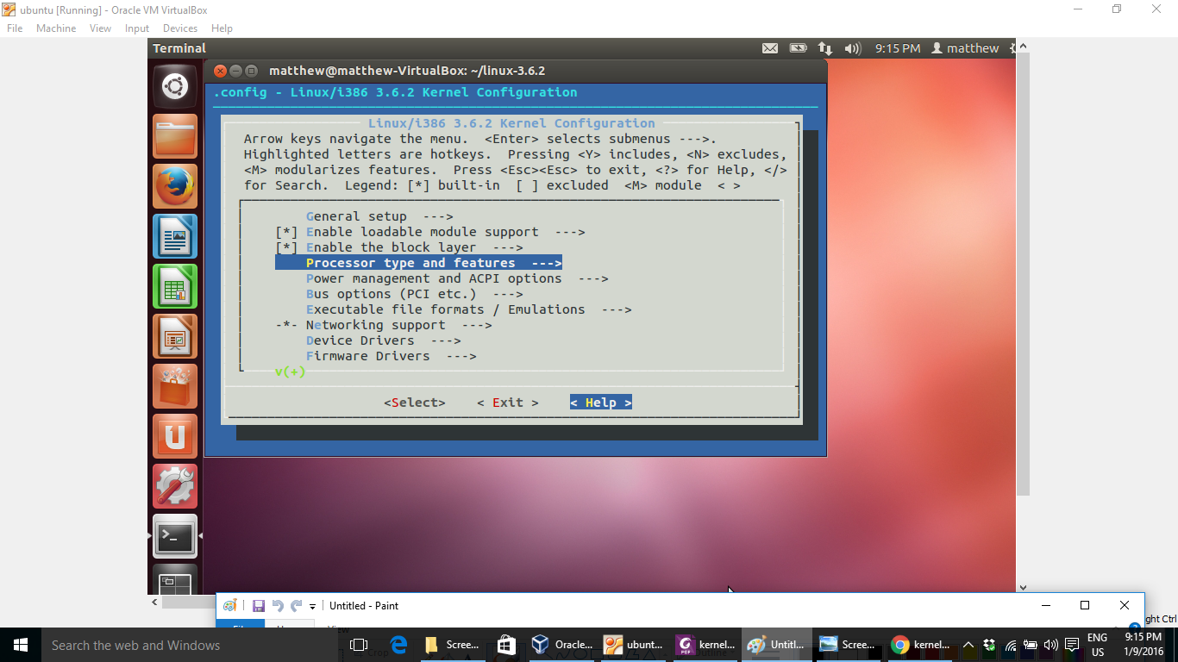

Figure 9 selecting the requirement items

Saving the menuconfig with the new name *.config_example*

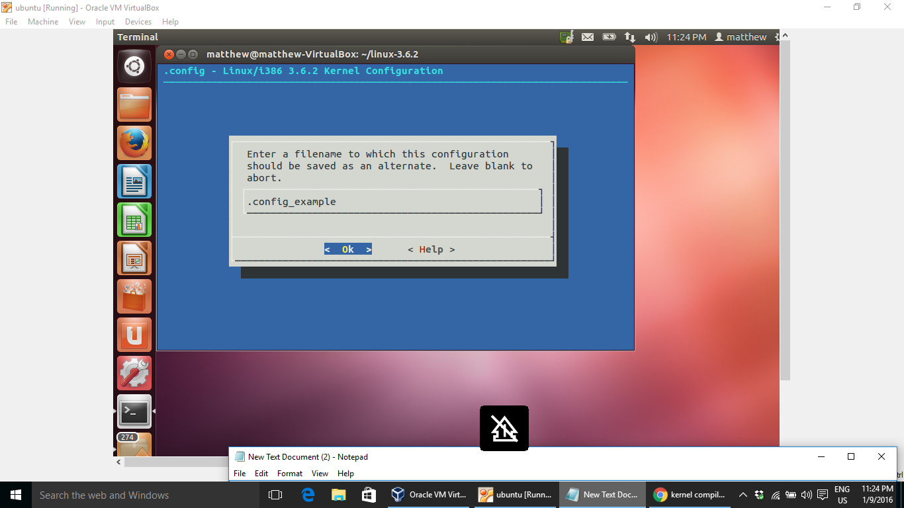

Figure 10 saving the config file

Renaming and making a backup of the configuration file by *mv .config_example .config*

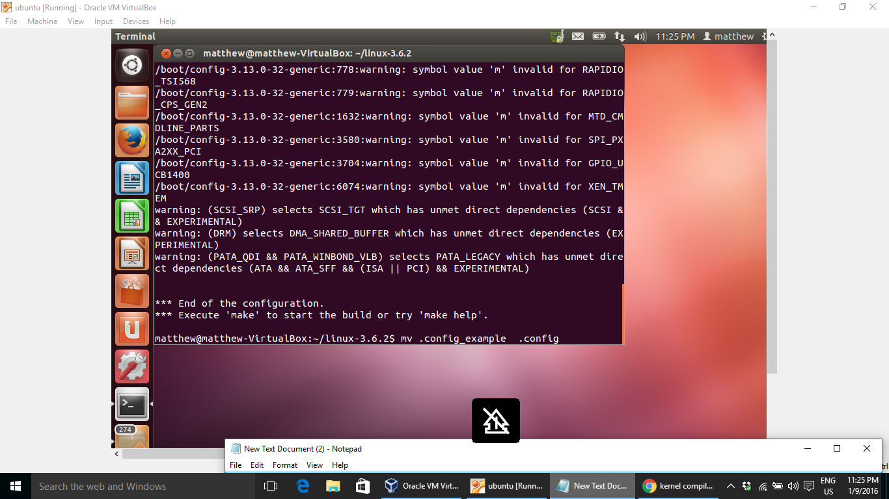

Figure 11 rename the config file

# Step 7: finding the number of cores which are existed on target PC by *system monitor* application

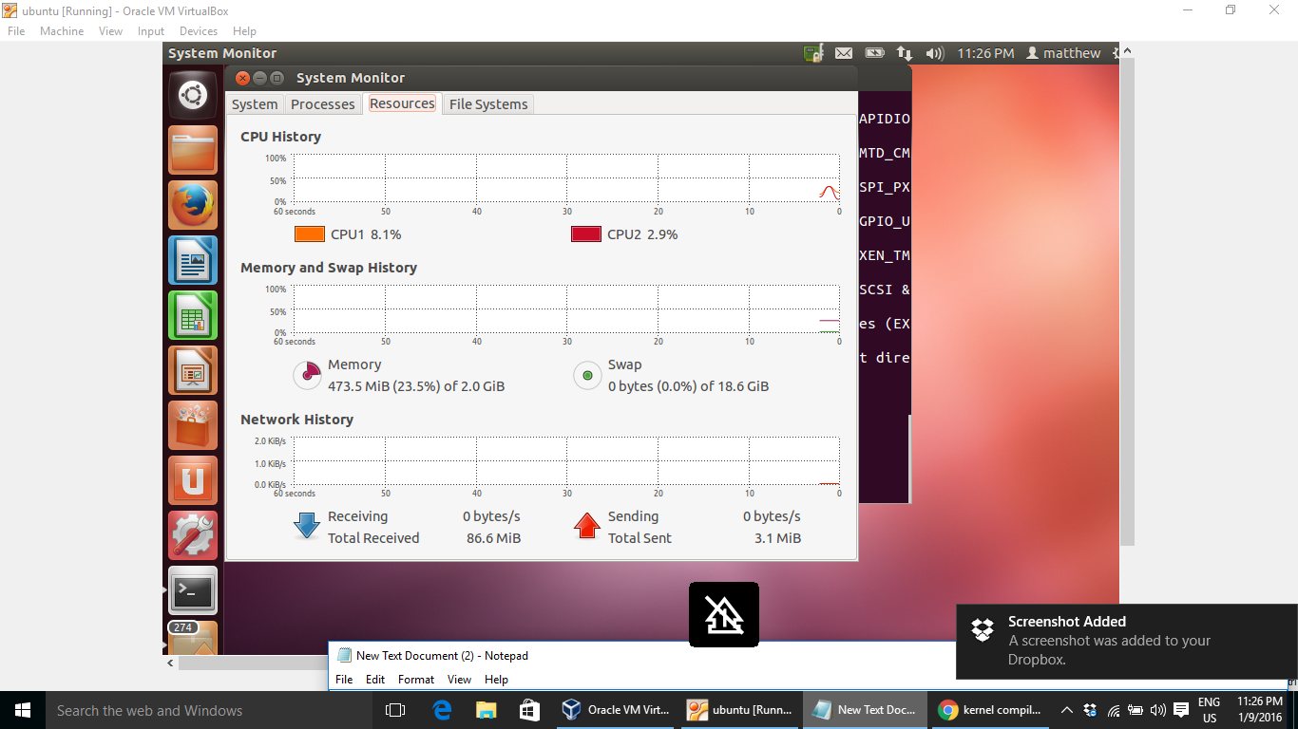

Figure 12 finding the number of cores to start compilation

# Step 8: starting to compile the source files of kernel by *make –j2*

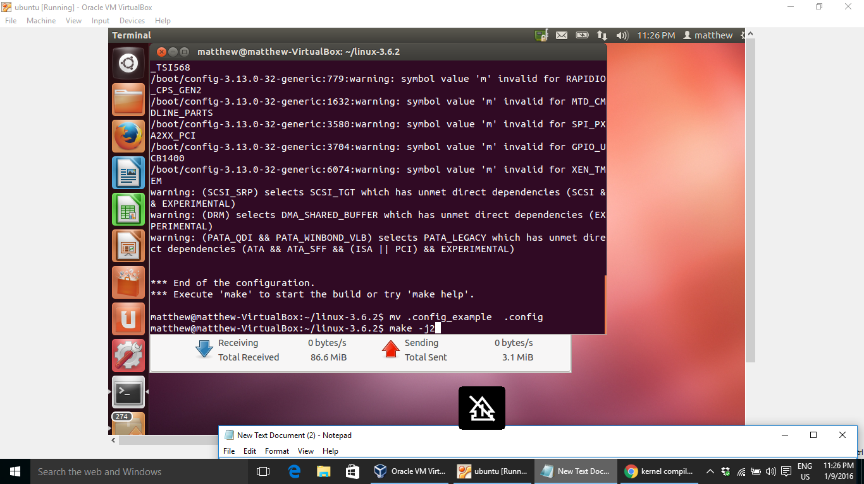

Figure 13 starting the compiling process

The state of processors during the compiling

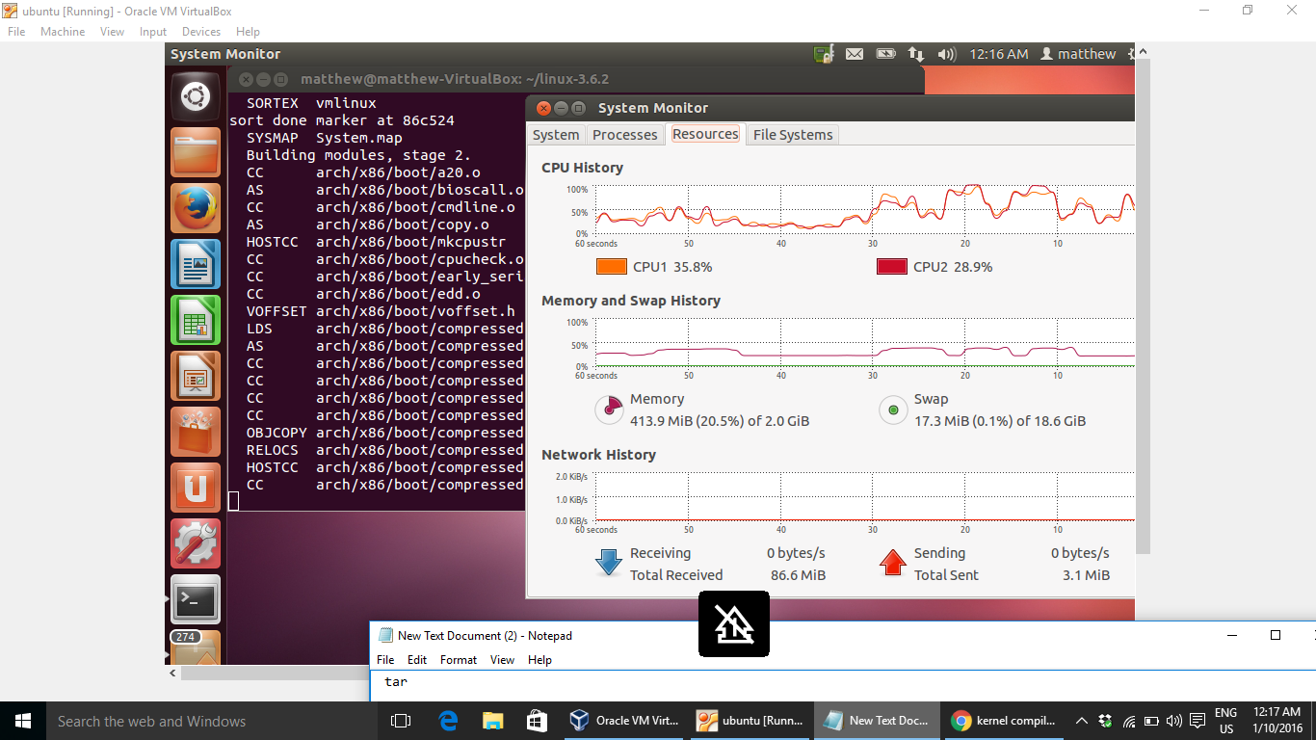

Figure 14 the processors state during compiling time

# Step 9: making the modules installer to starting modules installation on kernel by *sudo make modules_install*

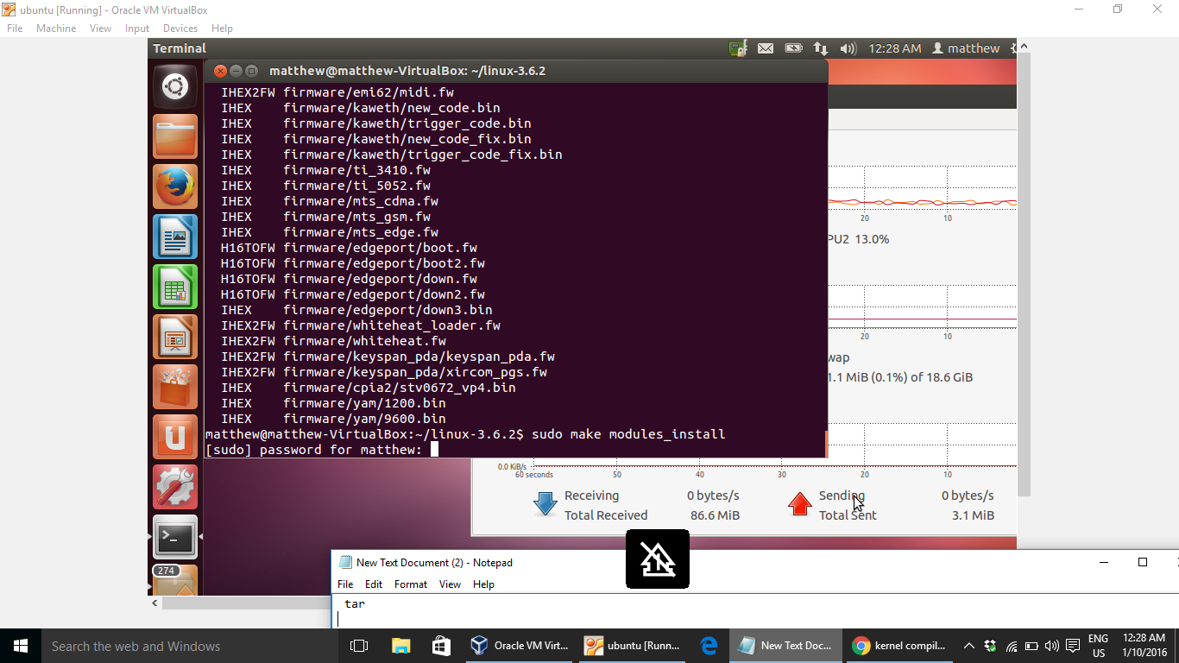

Figure 15 making the modules installer

# Setp 10: starting to install the new compiled kernel by *sudo make install*

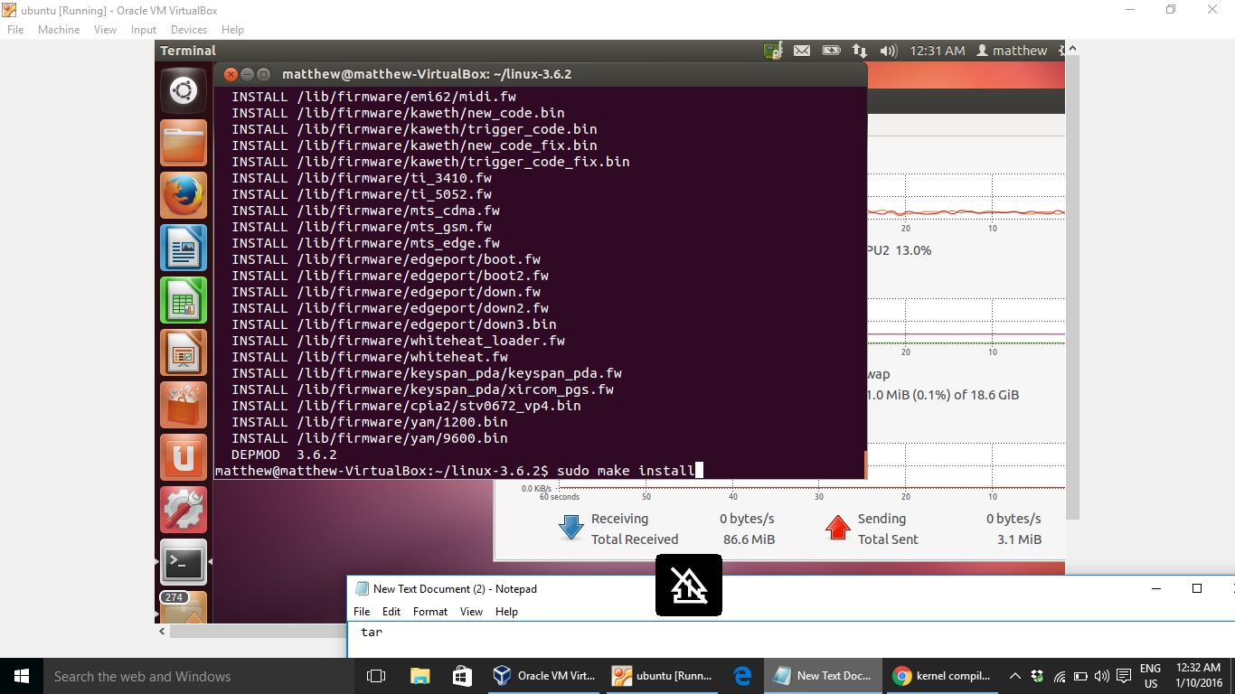

Figure 16 installation starts

# Step 11: checking the Linux version by *uname –r*

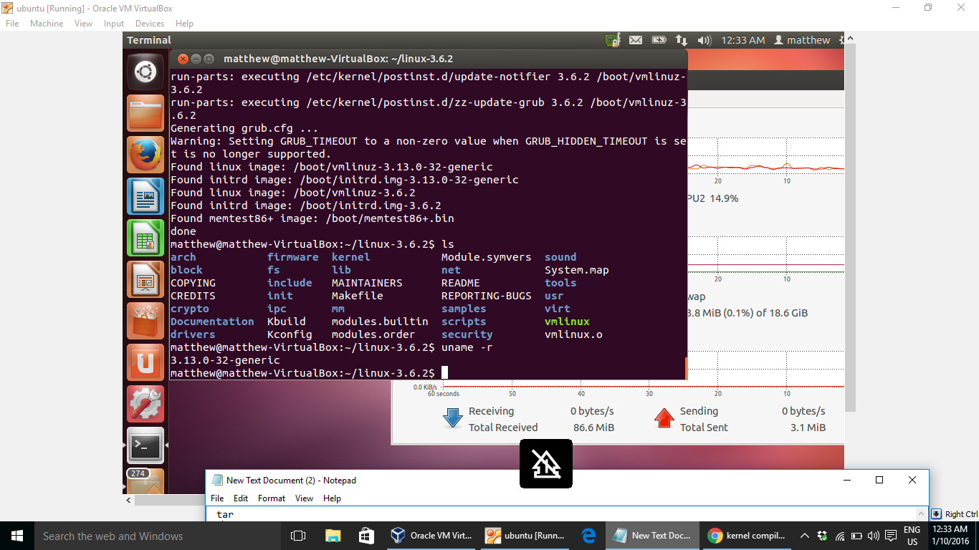

Figure 17 checking the installed files and Linux version

# Step 12: rebooting the OS to enter with new installed kernel by *sudo reboot*

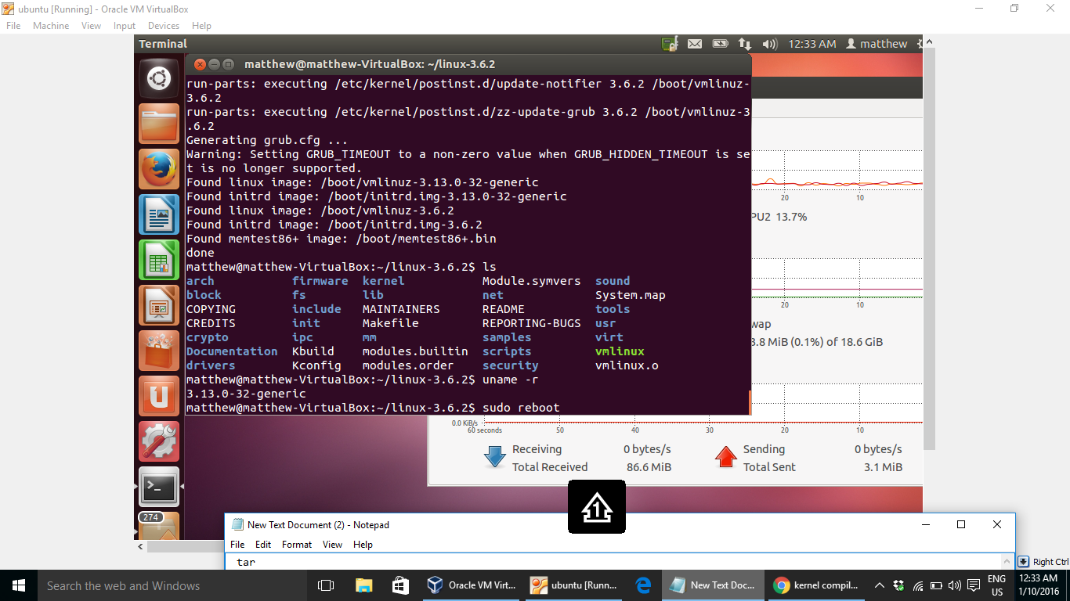

Figure 18 rebooting the OS

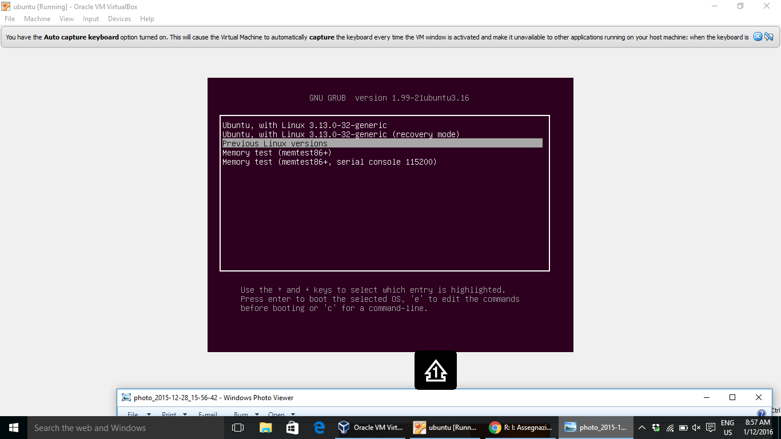

Figure 19 keeping the SHIFT-KEY to open the boot-dialog’s browser

# Step 13: starting the system with Linux 3.6.2

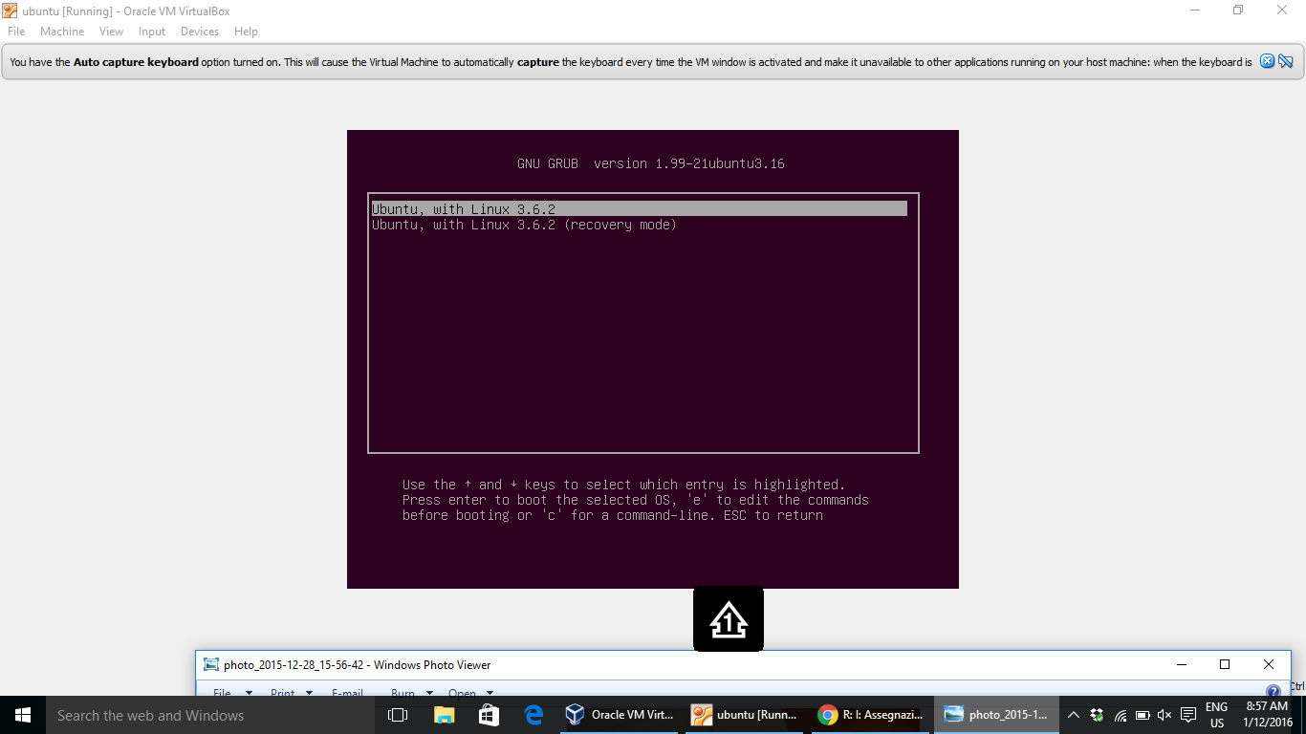

Figure 20 new kernel started